Spark Automation framework

Installation and Prerequisites

Prerequisites:

1. Pycharm or any python IDE
2. Git

Installation:

Clone the below repository:

[**https://github.com/swapnilspra/spark-automation-framework.git**](https://github.com/swapnilspra/spark-automation-framework.git)

**pycharm setting:**

Add source folder in pycharm setting as below:

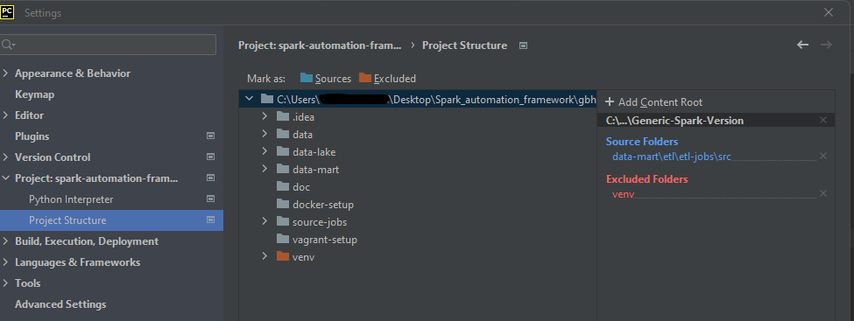

Pycharm terminal setting:

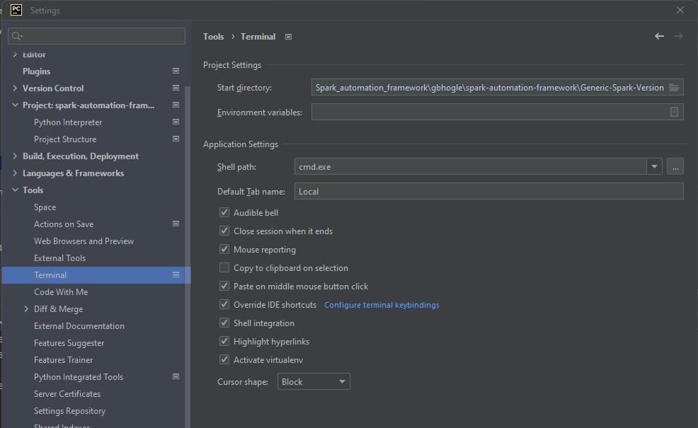

Open terminal in pycharm:

Run below command in terminal (Make sure requirement.txt file is present in the folder):

pip install -r requirement.txt

**Run configuaration:**

